Heroin Response Strategy
Annual Program Report for 2016

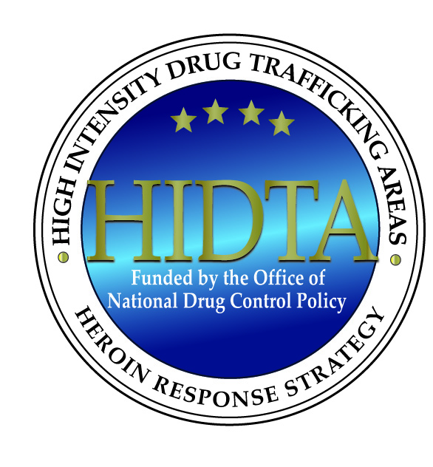

Investing in partnerships to build safe and healthy communities

Executive Summary
The United States is facing an opioid epidemic. Opioid deaths have quadrupled since 1999 and the rate of overdose deaths involving heroin increased 20 percent between 2014 and 2015 (CDC, 2016). The High Intensity Drug Trafficking Area (HIDTA) program’s response to the crisis includes the development of the Heroin Response Strategy (HRS), a multi-HIDTA, cross-disciplinary approach that develops partnerships among public safety and public health agencies at the Federal, state and local levels to reduce drug overdose fatalities and disrupt trafficking in illicit opioids. By the end of 2017, the HRS will be fully implemented in 20 states across eight HIDTAs.
At the foundation of the HRS is the Public Health and Public Safety Network (PHPSN). The PHPSN comprises cross-disciplinary teams of drug intelligence officers (DIOs) and public health analysts (PHAs) within each state. These teams are designated as “points of light” within their state, tasked with communicating information and collaborating across agencies and with other states in the HRS.
DIOs in each state are supported by a Public Safety Coordinator who works to ensure a regional approach to the opioid crisis. Because drug distribution takes place across regional and state borders and drugs users cross regional and state lines, the HRS response spans geographic boundaries. The DIO Network has streamlined the process for sharing felony drug arrest data across jurisdictions. The DIOs receive information about felony drug arrests from multiple sources and connect the arresting agency with appropriate in- and out-of-state law enforcement agencies. In several cases, information sharing has led to the identification of drug distributors linked to fatal opioid overdoses, and the information has been critical to disrupting distribution networks.
The Public Health Coordination Team (PHCT) works closely with the PHAs coordinating public health initiatives. Many PHAs have been able to help partner agencies gain access to fatal and non-fatal overdose data and made use of data in innovative ways.
Coordination between PHAs and DIOs has been critical to the success of the project. In addition to providing information on drug use and trafficking, the project has developed and disseminated prevention activities, including a parent helpline and online materials. HRS has also hosted several conferences to support sharing information across disciplines, functions, and geographic areas.
Plans for the HRS in 2017 include fully implementing the project in 20 states; strengthening collaborative relationships; working with the Centers for Disease Control and Prevention (CDC) to integrate the work of HRS with other Federal grant programs; and improving data sharing, data analysis, and use of evidence-based multi-sector approaches. HRS also plan to conduct an evaluation to identify best practices for further project implementation.
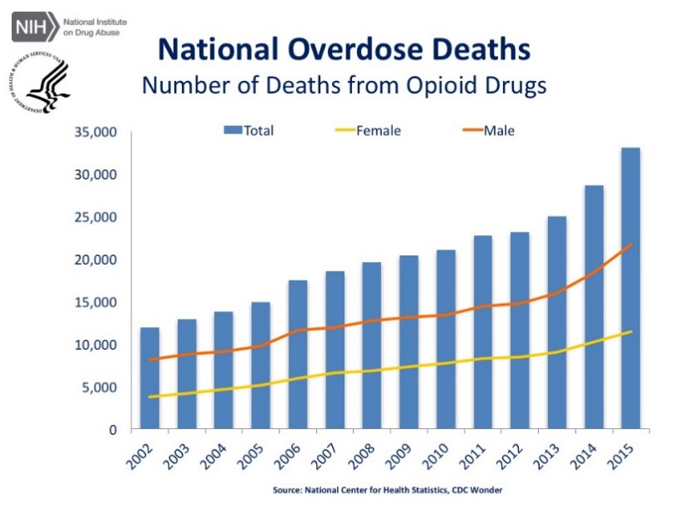
Overview
The opioid epidemic continues to escalate throughout the United States, claiming an alarming number of lives each year. Drug overdose is now the leading cause of accidental death in the U.S., surpassing automobile crashes since 2009 (Rudd et al., 2016). According to data released by CDC, drug overdoses accounted for more than 52,000 U.S. deaths in 2015, and of those, more than 33,000 (63 percent) involved an opioid (CDC, 2016). Overdose deaths from opioids have quadrupled since 1999 (CDC, 2016). Between 2014 and 2015, the rate of drug overdose deaths involving heroin increased 20 percent (CDC, 2016). The rate of overdose deaths involving synthetic opioids other than methadone also increased 72 percent during the same time period. This increase is likely to have been caused by the availability of illicitly manufactured fentanyl (Rudd et al., 2016).

States with statistically significant drug overdose death rate increases from 2014 to 2015
(Note: All but four of these states are currently included in the HRS) 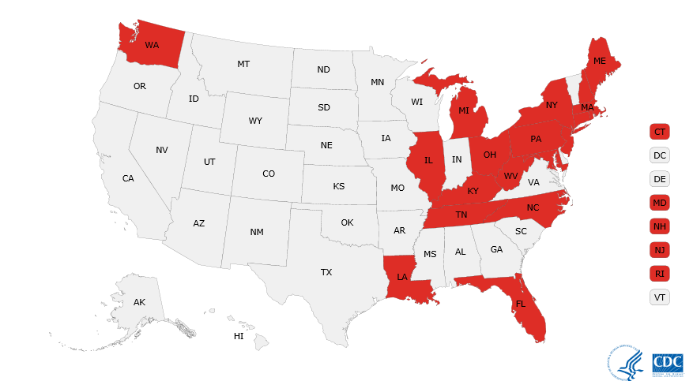

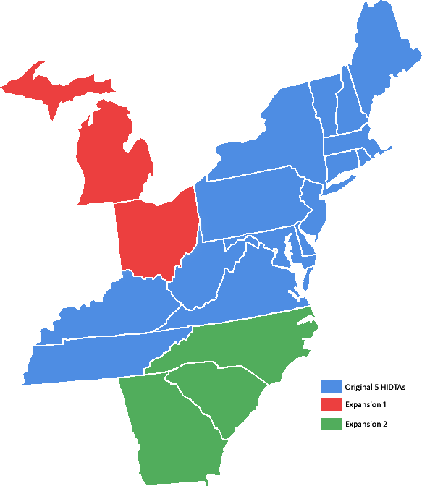
In August 2015, five HIDTAS – Appalachia, New England, New York/New Jersey, Philadelphia/Camden, and Washington/Baltimore –were awarded funding by Office of National Drug Control Policy (ONDCP) to address the regional nature of the opioid crisis. This multi-HIDTA partnership, comprising 15 states, formed the basis for the Heroin Response Strategy (HRS), a cross-disciplinary initiative that brings public health and public safety partners together at the Federal, state, and local level to reduce drug overdose fatalities and disrupt trafficking in illicit opioids. During the first year of HRS implementation, the need for expansion of the initiative was immediately recognized. Additional funding allocated by ONDCP in 2016 supported the expansion of the HRS to include the Ohio and Michigan HIDTAs, and, later, the Atlanta/Carolinas HIDTA. This funding brought new resources and a focused strategy to five additional states that have been deeply affected by the opioid epidemic. In 2017, the Heroin Response Strategy will be fully implemented in 20 states across eight HIDTAs.

Public Health Public Safety Network
To address the opioid epidemic affecting the HIDTA region, the HRS seeks to build meaningful partnerships between public health and public safety agencies in order to increase collaborative solutions and data sharing.
The cornerstone of the HRS is the Public Health and Public Safety Network (PHPSN), which comprises one drug intelligence officer (DIO) and one public health analyst (PHA) in each of the HRS states. Each DIO and PHA is responsible for helping to increase communication and data and intelligence sharing within their state. The Public Safety Coordinator (PSC) and Public Health Coordination Team bring a regional approach to the effort, collaborating to ensure the network forges lasting cross-disciplinary partnerships throughout the states and region. By designating the DIOs and PHAs as “points of light” within each state for issues and policies related to the opioid epidemic, communication across agencies and groups is easier and more efficient, and information is shared more quickly and widely.

DIO Accomplishments
The PSC shapes and coordinates the interstate Drug Intelligence Officer (DIO) Network, ensuring utilization of the regional intelligence-sharing network. Because drug distribution organizations operate across regions without regard for jurisdictional boundaries, dismantling them requires the collaboration of partners spanning various states. The HRS brings an innovative approach to current law enforcement models, one that is designed to yield smarter responses to expansive and increasingly sophisticated drug trafficking and distribution threats.
Each state DIO is located at one of the HIDTA Investigative Support Centers (ISCs) or at a partner agency, such as the state police, a key state task force, or a state fusion center. The DIO serves as a communication point within the state for reporting cross-jurisdictional drug trafficking links, disseminating interstate drug intelligence, making case referrals, and enhancing drug investigations. The DIO Network relies heavily on each DIO’s extensive law enforcement experience and contacts throughout their state. In 2016, the DIOs built significant contacts in their respective public safety and public health areas, generating greater awareness of the HRS initiative and expanding the geographical reach and impact of the DIO network.
In November 2016, all DIOs who were part of the HRS program gathered in Baltimore, Maryland for a two-day conference where they reported on key accomplishments and contributions to the HRS program. All DIOs reported that opioids, especially heroin and fentanyl, continued to represent the major drug threat in their states, and that heroin laced with fentanyl had become very common. Some DIOs also reported the presence of fentanyl-laced cocaine in their states.
In 2016, the DIOs also successfully streamlined the process for sharing felony drug arrest information across jurisdictions, filling a critical intelligence-sharing gap. Through the Felony Arrest Notification program, DIOs track and relay drug-related felony arrests of out-of-state and out-of-area residents and report this information to the individual’s home law enforcement agency. DIOs receive information about felony drug arrests from multiple sources, including a central state repository, law enforcement agencies throughout the state, and open source information (e.g., news articles). This information is used to connect the arresting agency to the appropriate out-of-state and in-state law enforcement agency to facilitate intelligence sharing. HRS DIOs have sent more than 6,000 Felony Arrest Notifications since January 2016. In several instances, the sharing of drug intelligence across the HRS network has enabled the DIOs to identify heroin/fentanyl distributors linked to outbreaks of fatal and non-fatal opioid overdoses, thereby enabling law enforcement authorities to disrupt the distribution of the drugs.
Success Story

Ohio, West Virginia, and Kentucky experienced a rash of opioid overdoses in the summer of 2016. More than 200 overdoses were reported, including several fatal overdoses found to involve carfentanil, a fentanyl analog. The Huntington, West Virginia area alone experienced 28 overdoses and two deaths linked to carfentanil within a four-hour period on August 15. The outbreak prompted the DIO from West Virginia to contact his counterpart in Ohio to compare notes and share relevant information. The DIOs were able to connect two separate investigations linked to the carfentanil outbreak, one in Huntington, West Virginia and the other in Summit County, Ohio. These efforts assisted Federal authorities in the identification and subsequent arrest of the person responsible for distributing the deadly drug in three states.

In addition to making thousands of felony arrest notifications, HRS DIOs provided leads and case support to law enforcement agencies in more than 200 instances in 2016, offering critical support to a range of criminal investigations. DIOs also shared information and intelligence gathered from various investigative tools (e.g., license plate readers, facial recognition programs and Division of Motor Vehicle photo programs) with law enforcement agencies across the HRS region.
Since the first year of the program, DIOs have communicated frequently with their in-state law enforcement partners to encourage the expansion of law enforcement participation in the HRS program. DIOs attended numerous meetings, including gatherings of chiefs of police, sheriffs associations, and other relevant law enforcement agencies within their state to further the reach of the HRS Program. Many DIOs are now participating in state-level opioid task forces, and deliver valuable intelligence and information related to the opioid epidemic within their states.
Each DIO has also developed a close working relationship with the PHA in the state. Through daily or weekly communication, the DIO and PHA identify emerging trends and address shared concerns and other issues affecting implementation of the HRS Program. In 2016, these partnerships resulted in the sharing of actionable intelligence related to both outbreaks of opioid overdose and heroin trafficking “hot spots.” This intelligence was then provided to the law enforcement and public health communities.
Success Story

In April 2016, the Delaware PHA received information from his public health contacts that a heroin stamp branded “ACURA” was found at the site of a fatal overdose in Delaware. Testing of the stamp indicated the presence of fentanyl. The PHA passed this information to the Delaware DIO, who then made a request to the Washington-Baltimore HIDTA for information regarding the “ACURA” stamp. Information compiled by the Washington-Baltimore HIDTA indicated that the stamp had been recently purchased by the Smyrna, Delaware Police Department (PD). The Delaware HRS team immediately shared this actionable intelligence with the Smyrna PD, who moved quickly to conclude their investigation. Smyrna PD served several search warrants, seizing 332 bags of heroin stamped “ACURA,” confiscating $2,900 in suspected drug proceeds, and making an arrest. A confidential source indicated that the source of the heroin supply was based in Elkton, Maryland. The Delaware DIO shared this information with the Maryland DIO, who then alerted the Cecil County Task Force (CCTF) for further investigation. The HRS’ timely information sharing connected law enforcement investigations and assisted in the identification and elimination of a serious public safety and public health threat.

As illustrated in the HIDTA Performance Measurement (PMP) System, the HRS accomplished among other things, the following during 2016:
- Identified 146 new Drug Trafficking Organizations (DTOs) and enhanced 40 existing DTOs

- Made 4,737 entries into Case Explorer

- Provided 6,521 felony drug arrest notifications

- Referred 91 individuals to public health agencies for follow-up

PHA Accomplishments
The Public Health Coordination Team (PHCT) coordinates and advises the interstate PHA Network, assisting with public health data-related efforts, facilitating key connections within and between states, and coordinating regional public health and emerging trend analyses. In January 2016, the original five HIDTAs contracted with the Institute for Research, Education and Training in Addiction (IRETA) to serve as the PHCT. Similar to patterns in drug trafficking, trends in drug use and drug user safety are better viewed regionally. In many cases, new fentanyl analogs appear in one state just days or weeks before becoming available in other states. By creating a network of public health professionals across a larger region, important information about drug trends can help local agencies to prepare for change in their environment.
One of the principle goals of the PHA network is to enhance the timeliness and accuracy of state drug use indicator data, such as data on overdose deaths and naloxone distribution. In order to provide accurate and timely trend analyses and implement data-driven policies, each state must have accurate and up-to-date information about drug use in their jurisdiction. In particular, with the pace at which new opioids are entering the market in the U.S. today, it is vitally important that government officials develop interventions based on knowledge of what drugs are most dangerous and which groups of people are most at risk.
In February 2016, the PHAs attended an extensive orientation and training session in Philadelphia. There, the PHCT trained the PHAs to understand how drug use indicator data is collected and analyzed, and how to evaluate the quality of the respective states’ data. The PHAs then engaged in an environmental scan to determine the timeliness and quality of overdose death data and other drug use indicator data in their respective states. Through this process, the PHAs identified the current capabilities of each state health authority, including information about the quality of the analyses they provide and which key drug use indicator datasets were being collected, analyzed, and disseminated to key partner agencies. Many PHAs identified significant gaps in the data, including key indicators of drug use and emerging trend information, which is frequently unavailable, incomplete, or outdated. While some states track overdose death data in nearly real time, other states are challenged by significant time gaps of up to 18 months. Nearly all states in the HRS face a lack of availability of non-fatal overdose data; thus, a key objective of the PHPSN is to improve the collection, analysis, and dissemination of these indicators.
Success Story

In New York, the PHA was a member of a team at the New York State Department of Health that created the Opioid County Quarterly Reports. These reports assess county level data on fatal overdoses, treatment requests, and drug related emergency room visits. The reports are now publicly available through the website and updated quarterly. The PHA played a key role in writing a methodology guide for the website that outlines for local public health departments the specific terms that the state health officials used to get to their final numbers for each county. As a result, local health departments around the state are working to standardize the reporting across hospitals and treatment facilities to improve accuracy of reporting. The PHA also played a key role in helping the Department of Health decide which indicators would be most valuable after pulling and analyzing information from multiple datasets.

In addition to working toward making fatal overdose data more accessible to partner agencies, some PHAs have made innovative inroads into analyzing other drug use indicator data. In Maryland, law enforcement agencies use the Case Explorer database to input arrest and case information. As part of the PHPSN strategy in the state, non-fatal overdose incident information handled by law enforcement agencies is also being entered into Case Explorer. The PHA in Maryland was able to take the information collected by local law enforcement about non-fatal overdoses and analyze it for patterns. Based on an individual’s number of non-fatal overdoses, and the time between these overdose incidents, the Maryland PHA is now able to provide a monthly list of the individuals most at risk of a fatal overdose to local public health agencies and treatment providers to help them prioritize high risk individuals for outreach.
Ongoing collaboration between PHAs with their DIO counterparts has been a critical component of the project during the first year. The role of the PHA/DIO team in each state is to continuously facilitate cross-discipline data sharing and analysis, thereby better informing operational efforts in each state.
In addition, many PHAs have participated in, or helped to create state and local task forces aimed at combatting the opioid epidemic. By working to build coalitions and interagency collaboration, the PHAs are strengthening the HRS network and helping to make the initiative more efficient and effective. Bringing together diverse stakeholders also creates opportunity for innovation and encourages the use of best practices across agencies.
Success Story

In Rhode Island, the PHA and DIO obtained information about the presence of carfentanil, U4700, and W-18 in their state, and created a public health-public safety bulletin about the forms the drugs were found in and the specific dangers of these drugs. To create this bulletin, they relied on information from local police departments as well as the toxicology laboratory at the Rhode Island Department of Health. The bulletin was then shared with local and state public health and public safety agencies.
PHAs also contributed to the development and submission of multiple grants throughout the year, several of which have been funded. In New Jersey, the PHA co-authored a grant application for the Centers for Disease Control and Prevention’s (CDC) Data-Driven Prevention Initiative and contributed to a report on the Substance Abuse and Mental Health Services Administration’s (SAMHSA) prevention grant that was recently awarded to the Department of Homeless Services, resulting in significant increases in funding for surveillance, prevention, and treatment efforts in the state. Likewise, the PHA in Delaware helped to write a proposal for a National Governors Association (NGA) Learning Lab grant that made it possible for the state to produce a quarterly bulletin on drug overdoses and law enforcement drug seizures in the Delaware. The PHA also helped to create an Action Committee that analyzes and acts on the data in these quarterly bulletins. This committee comprises officials from numerous state and local agencies.
Success Story

The PHA in Kentucky helped the U.S. Attorney for the Western District of Kentucky plan a Heroin and Opioid Response Summit in Jefferson County to address gaps in resources, determine and distribute best practices, and foster collaboration among agencies in and around Louisville. The PHA played a key role in connecting the U.S. Attorney’s office with officials at the Kentucky Hospital Association, the local poison control center, and other public health stakeholders. She also helped the U.S. Attorney’s office select topics and key partners for panels at the summit. As a result of this meeting, interagency communication has increased and there is now a Drug Enforcement Administration (DEA) task force to investigate fatal overdoses that involves input from the Louisville Metro Department of Health and Wellness.

Each PHA operates in a different environment depending upon office location, nature of the local heroin/opioid threat, and the current status of collaboration, data-sharing, and data analysis in their state. As a result, PHAs are serving in a range of roles that depend on the needs of their state. The PHCT continues to assist the PHAs in identifying and defining the most appropriate roles that fit within the purposes of the HRS. PHAs also work with their state DIOs and PHAs from other states to understand how their state is similar or different from other states in the region.

Joint Fentanyl Report

In July 2016, every PHA and DIO completed a joint report on the presence and status of fentanyl in their state. In addition to the individual state reports, the information collected was used to produce larger regional reports describing fentanyl use and trends throughout the HRS. These reports included input from medical examiners and coroners, treatment providers, prevention and harm reduction organizations, public health personnel, and local, state, and federal law enforcement. Information was collected via surveys, face-to-face interviews, and round table discussions on several topics including fentanyl trafficking, product distribution and surveillance, overdoses and overdose fatalities, and awareness and prevention efforts. The findings from the West Virginia and Pennsylvania state reports were used as background for a briefing on fentanyl briefing provided by the CDC to congressional staffers on fentanyl across the U.S.

All participating HIDTAs reported that fentanyl trafficking was a significant issue in their states, further validating concerns regarding the presence of fentanyl throughout the HRS. Despite some variation, reporting suggested that the presence of fentanyl was often unknown to street dealers and buyers. Products laced with fentanyl were reportedly cut prior to distribution to lower-level dealers, reducing the chance of their awareness of its presence. However, when dealers were aware of fentanyl’s presence, some did inform buyers of its potential existence. Other dealers used it as a marketing tool, telling buyers it could provide them with a stronger high, suggesting that some individuals actively seek out fentanyl. Findings appeared to show that, while most users had heard of fentanyl, the majority of users were unaware of the elevated risks associated with fentanyl and its differences relative to other opioids.
The HIDTAs reported that the majority of fentanyl testing was conducted in laboratory settings following seizure, as opposed to being tested by law enforcement. This was largely attributed to the lack of a reliable field test, as well as to safety concerns related to the dangers of handling fentanyl. The frequency with which test results were shared also varied among HIDTAs and individual states. A handful reported that they routinely shared test results with outside agencies and across jurisdictions, but many did not. There was general agreement that fentanyl was routinely screened for by toxicologists in cases of suspected overdose, although some exceptions were noted within particular states. In contrast, testing for specific fentanyl analogues, such as acetyl fentanyl or furanyl fentanyl, was less consistent.
The joint reports supported that the availability of naloxone has consistently increased across the entire region. However, there was widespread agreement that there would likely be a shortage of naloxone in the event of a spike in overdoses. The reports also concluded that there was a significant need for enhanced collaboration between public health and public safety entities and that such partnerships have demonstrated the potential for reducing fentanyl-related harm and overdose. Public health and public safety entities have both demonstrated a shift towards increased data gathering and data sharing in order to better monitor trafficking trends. Additionally, both public safety and public health entities are increasingly supportive of diversion programs that offer treatment to users as an alternative to incarceration.
Community Education with Partnership for Drug-Free Kids
The prevention initiative implemented in collaboration with the Partnership for Drug-Free Kids (PDFK) aims to prevent youth substance use by educating and mobilizing parents in communities throughout the HRS. Work officially began on the HIDTA/PDFK collaboration on December 1, 2015, and involved three primary elements: online education and tools, community education, and professional and peer-to-peer parent support, together comprising the “Heroin + Other Opioids” project.
Since officially initiating the project, PDFK has designed and developed a mobile-friendly online hub at drugfree.org/heroin that includes the following elements:
- Information about heroin and other opioids, and the link between prescription drug use and use of other opioids.

- Information about how to safeguard and properly dispose of medications; how parents can communicate with their kids about substance abuse; how families can get help for loved ones, including a treatment e-book and a medication-assisted treatment (MAT) e-book; and online treatment locators, including Federal (SAMHSA) and state treatment locator tools and MAT treatment locator tools.

- Resources that groups and individuals can use to protect their community, including a safe disposal guide, a documentary about teen prescription drug use, and information about naloxone and Good Samaritan laws.

- A directory of local information, which includes access to state substance abuse agencies, state level heroin and other opioid initiatives, and the Partnership’s state and city alliance programs.

- Access to the community education presentation, “Heroin and Other Opioids.” On the hub, visitors can sign up to receive updates and information; download two versions of the presentation – one for community mobilization and another for parent education – as well as speaker’s notes for each version; access a handout for audience members that includes a link to a survey where they can provide feedback on the presentation; obtain a guide to implementing community education programs; and find a link to an online event report that presenters can submit after presentations.

- A 90-second video entitled Epidemic, created by award-winning advertising agency Thornberg and Forester, which combines statistics, storytelling, and 3D animation to illustrate the devastation of the epidemic to communities across America.
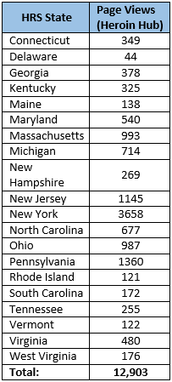
Drugfree.org/heroin was officially launched at the National Rx Drug Abuse & Heroin Summit in Atlanta on March 29, 2016. Since the launch of the site, the “Heroin + Other Opioids” hub has become one of the most visited resources on the Partnership website. From April 1 through December 31, 2016, more than 58,000 individuals viewed the hub, spending an average of three minutes and nine seconds on the page (triple the time on site of the home page). Traffic to the Partnership website overall has increased since the launch of the hub as well. Since August , 2016, an average of 381 individuals have visited the Partnership website each day.
The video Epidemic has also been widely viewed. In addition to being viewed by every visitor to the hub, the video has been viewed more than 11,000 times on YouTube and more than 11,000 times on Facebook.
Between April 1 and December 31, 2016, the Community Mobilization presentation was downloaded 276 times and the Parent Education presentation was downloaded 216 times. The Partnership promoted the presentation at the Heroin Symposium in Towson, Maryland and held three train-the-trainer webinars in June and July, 2016. More than 80 people registered for the webinars and all registrants received links to a recording of the presentation.
The table on the right shows the number of times the “Heroin + Other Opioids” hub was viewed from March through December, 2016 by individuals in each of the 20 states involved in the HRS initiative.
Further, PDFK has used funding to enhance and expand parent support resources in the following ways:
- The Partnership Helpline is staffed by experienced bilingual social workers. Between April 1 and December 31st, 2016, the Helpline responded to 2,713 calls from families seeking all types of support – from communicating with a teen experimenting with substances to supporting a family member’s recovery. Of these calls, more than 1,171 were placed by individuals from HRS states, representing an 11 percent increase compared to the same time frame in 2015.

- Between April 1 and December 31st, 2016, more than 133 callers started Parent Coaching through PDFK, with 39 of these cases involving heroin or other opioids. Parent Coaching connects callers with Partnership parent volunteers who have personal experience with a child’s substance use and have been trained by the Partnership and the Center for Motivation and Change to help parents take care of themselves, find productive ways to communicate with their child, and move their child towards healthier behaviors, including treatment and recovery.
The Partnership has also undertaken two additional initiatives:
- Ask a Parent Coach: Visitors to the Heroin hub and the Partnership’s “Get Help” hub will be able to access a directory of questions frequently asked by parents of children with substance abuse problems. If their question is not on the list, they will be able to submit it to a Parent Coach who will respond within 24 hours. The Partnership seeks to launch these services early in 2017.

- Helpline Chat: To extend Helpline services, the Partnership is hiring two part-time Helpline specialists who will respond to online communications from parents and caregivers. The Partnership will launch this service as soon as qualified individuals are hired and trained.

State of the Region Public Health Public Safety Symposium
The HRS held a symposium at Towson University in Baltimore on June 22-23, 2016 that brought together the eight HIDTAs participating in the HRS. More than 300 attendees from 25 states took part in the event, which featured 45 speakers. Experts in drug enforcement, treatment, and prevention and public health officials from the CDC spoke about the heroin and opioid epidemic confronting the nation.
Day 1
The Symposium opened with remarks from Kim Schatzel, President of Towson University, William Ihlenfeld, II, USA Norther District of West Virginia, ONDCP Director Michael Botticelli, and National HIDTA Director Michael Gottlieb. These speakers set the stage for a wide range of speakers and panels.
NY/NJ HIDTA Director Chauncey Parker introduced Dr. Peter Luongo, the HRS Public Health Coordinator and Vito Guarino, the HRS Public Safety Coordinator, who provided an overview of the Public Health and Public Safety Partnership. This unique and critical partnership is the first of its kind designed to bridge the gap for sharing information and developing effective strategies drawing upon the expertise of both endeavors. The information sharing platform created by the Partnership is key to the success of the HRS.
A series of panels followed that highlighted best practices and provided information for developing new strategies to combat the heroin and opioid threat. The overwhelming consensus of the panels was that the heroin and opioid epidemic can only be stemmed with the combined and coordinated efforts of law enforcement, treatment, and prevention and public health organizations. To this end, HIDTA, DEA, the Organized Crime Drug Enforcement Task Forces (OCDETF) and the CDC announced a new effort to share information on-line using EPIC as a central hub. Work is currently underway on this project.
The Philadelphia-Camden HIDTA Director, Jerry Daley, introduced Secretary Brian Moran of the Virginia Department of Public Safety, the keynote speaker on the first day of the Symposium. Secretary Moran addressed the gathering on the impact heroin and opioid abuse was having on Virginia and stressed the importance of the work being done through the HRS.
The first day of the Symposium concluded with a presentation about the HRS’ work with PDFK. PDFK spokesman Kevin Collins provided the attendees with a demonstration of the “Heroin and Other Opioids” hub developed by PDFK with HRS resources.
Day 2
Hall of Fame baseball player Cal Ripken Jr. opened the second day of the Symposium by speaking about the need to work with at-risk children and the importance of programs that help youth make the right choices in life. He spoke extensively about the Badges for Baseball program and the great work being done by the Cal Ripken, Sr. Foundation.
Following an introduction by Michigan HIDTA Director Abe Azzam, Acting Administrator for the Drug Enforcement Administration Chuck Rosenberg discussed DEA’s efforts to confront the epidemic and how critical the HRS is to the overall effort. Shortly thereafter, Appalachian HIDTA Director Vic Brown welcomed speakers from the DEA Special Testing Laboratory who spoke on the fentanyl threat.
New England HIDTA Director Jay Fallon introduced keynote speaker Dr. Daniel Alford, from the Boston University School of Medicine, who discussed the importance of proper prescribing and its impact on the opioid epidemic.
Later in the afternoon, Washington/Baltimore HIDTA Director Tom Carr introduced Maryland Lt. Governor Boyd Rutherford, the architect of Maryland’s Heroin and Opioid Emergency Task Force plan. Lt. Governor Rutherford praised the work of the HRS and noted Maryland’s reliance on the HIDTA to coordinate information gathering in support of the Task Force.
The second day of the Symposium focused everyone on the need to view addiction as a disease and to devise solutions from the public health perspective. As with any disease, it is necessary to track its spread and develop strategic and tactical responses. All speakers emphasized that recognizing substance use disorder as a disease is the first step stopping the disease.
The Symposium concluded with an open discussion led by Directors Parker and Fallon on the next steps for the HRS. Atlanta-Carolinas Director Jack Killorin, who attended the conference, expressed his intent to join in the HRS as the eighth HIDTA partner. The Atlanta-Carolinas HIDTA officially joined the HRS in August 2016.
Next Steps for 2017: HRS 2.0
The HRS is building on the accomplishments from the previous year by continuing to enhance the collaborative nature of the initiative. As the initiative expands to 20 states, the PHPSN will continue to build on early successes, facilitating structured information sharing among the key stakeholders in each state, as well as across state boundaries, and facilitating rapid responses to identified threats.
By leveraging state opioid abuse prevention and surveillance efforts, the PHPSN can more efficiently build and strengthen information sharing networks. CDC, which has been an informal partner in this effort from the beginning, has formalized its relationship with the HRS and is serving in the role of HRS coordinator, on behalf of the HIDTA directors.
Building on successes and lessons learned from year one, and as part of its newly formalized collaboration with CDC, the HRS looks forward to implementing HRS 2.0 in year two of the program. HRS 2.0 will leverage CDC’s program development, implementation, and evaluation expertise to further refine and clarify the initiative’s strategic direction, vision, mission, and goals.
One important aspect of HRS 2.0 will be the implementation of a clear organizational structure, ensuring adequate representation and input from both public safety and public health. Through this structure, enhanced support will be provided to DIOs and PHAs through points of contact (POCs) assigned to each state. These POCs will assist with work plan development, reporting requirements and alignment of activities with HRS 2.0 goals, provide ongoing and frequent communication with PHAs and DIOs, and connect them to resources and subject matter experts. POCs will be supported by and report to a Public Health Team Lead and a Public Safety Team Lead, who in turn report to the HRS Director. Project oversight and guidance will continue to be provided by the HIDTA directors (See Appendix A for organizational chart).

Another aspect of HRS 2.0 will be the implementation of Cornerstone and Pilot Projects. POCs and CDC’s Science to Action Coordinator will help the PHA and DIO in each state complete a series of Cornerstone Projects designed by the Science to Action Coordinator to provide a comprehensive understanding of the strengths and weaknesses in each HRS state’s prevention, treatment, and response efforts. The goal of these Cornerstone Projects is to illuminate existing gaps in resources and to create recommendations for local officials to address opioid related public health and public safety issues in their communities. The Cornerstone Projects will also provide the HIDTA program and CDC with important regional information about relevant local law enforcement and public health efforts across all 20 HRS states.

The HRS Pilot Projects will focus on the implementation and evaluation of data-driven prevention initiatives in three to four “hotspots” across the HRS. CDC will work with the HIDTA program to identify these pilot sites and provide technical support on the implementation and evaluation of evidence-based prevention, treatment, and response initiatives. The Pilot Projects will provide the HDITA program and CDC with important information about the successes, challenges, and barriers to implementing these evidence-based interventions.

References
CDC. Wide-ranging online data for epidemiologic research (WONDER). Atlanta, GA: CDC, National Center for Health Statistics; 2016. Available at http://wonder.cdc.gov.

Rudd RA, Seth P, David F, Scholl L. Increases in Drug and Opioid-Involved Overdose Deaths — United States, 2010–2015. MMWR Morb Mortal Wkly Rep 2016;65:1445–1452.

Appendix A
