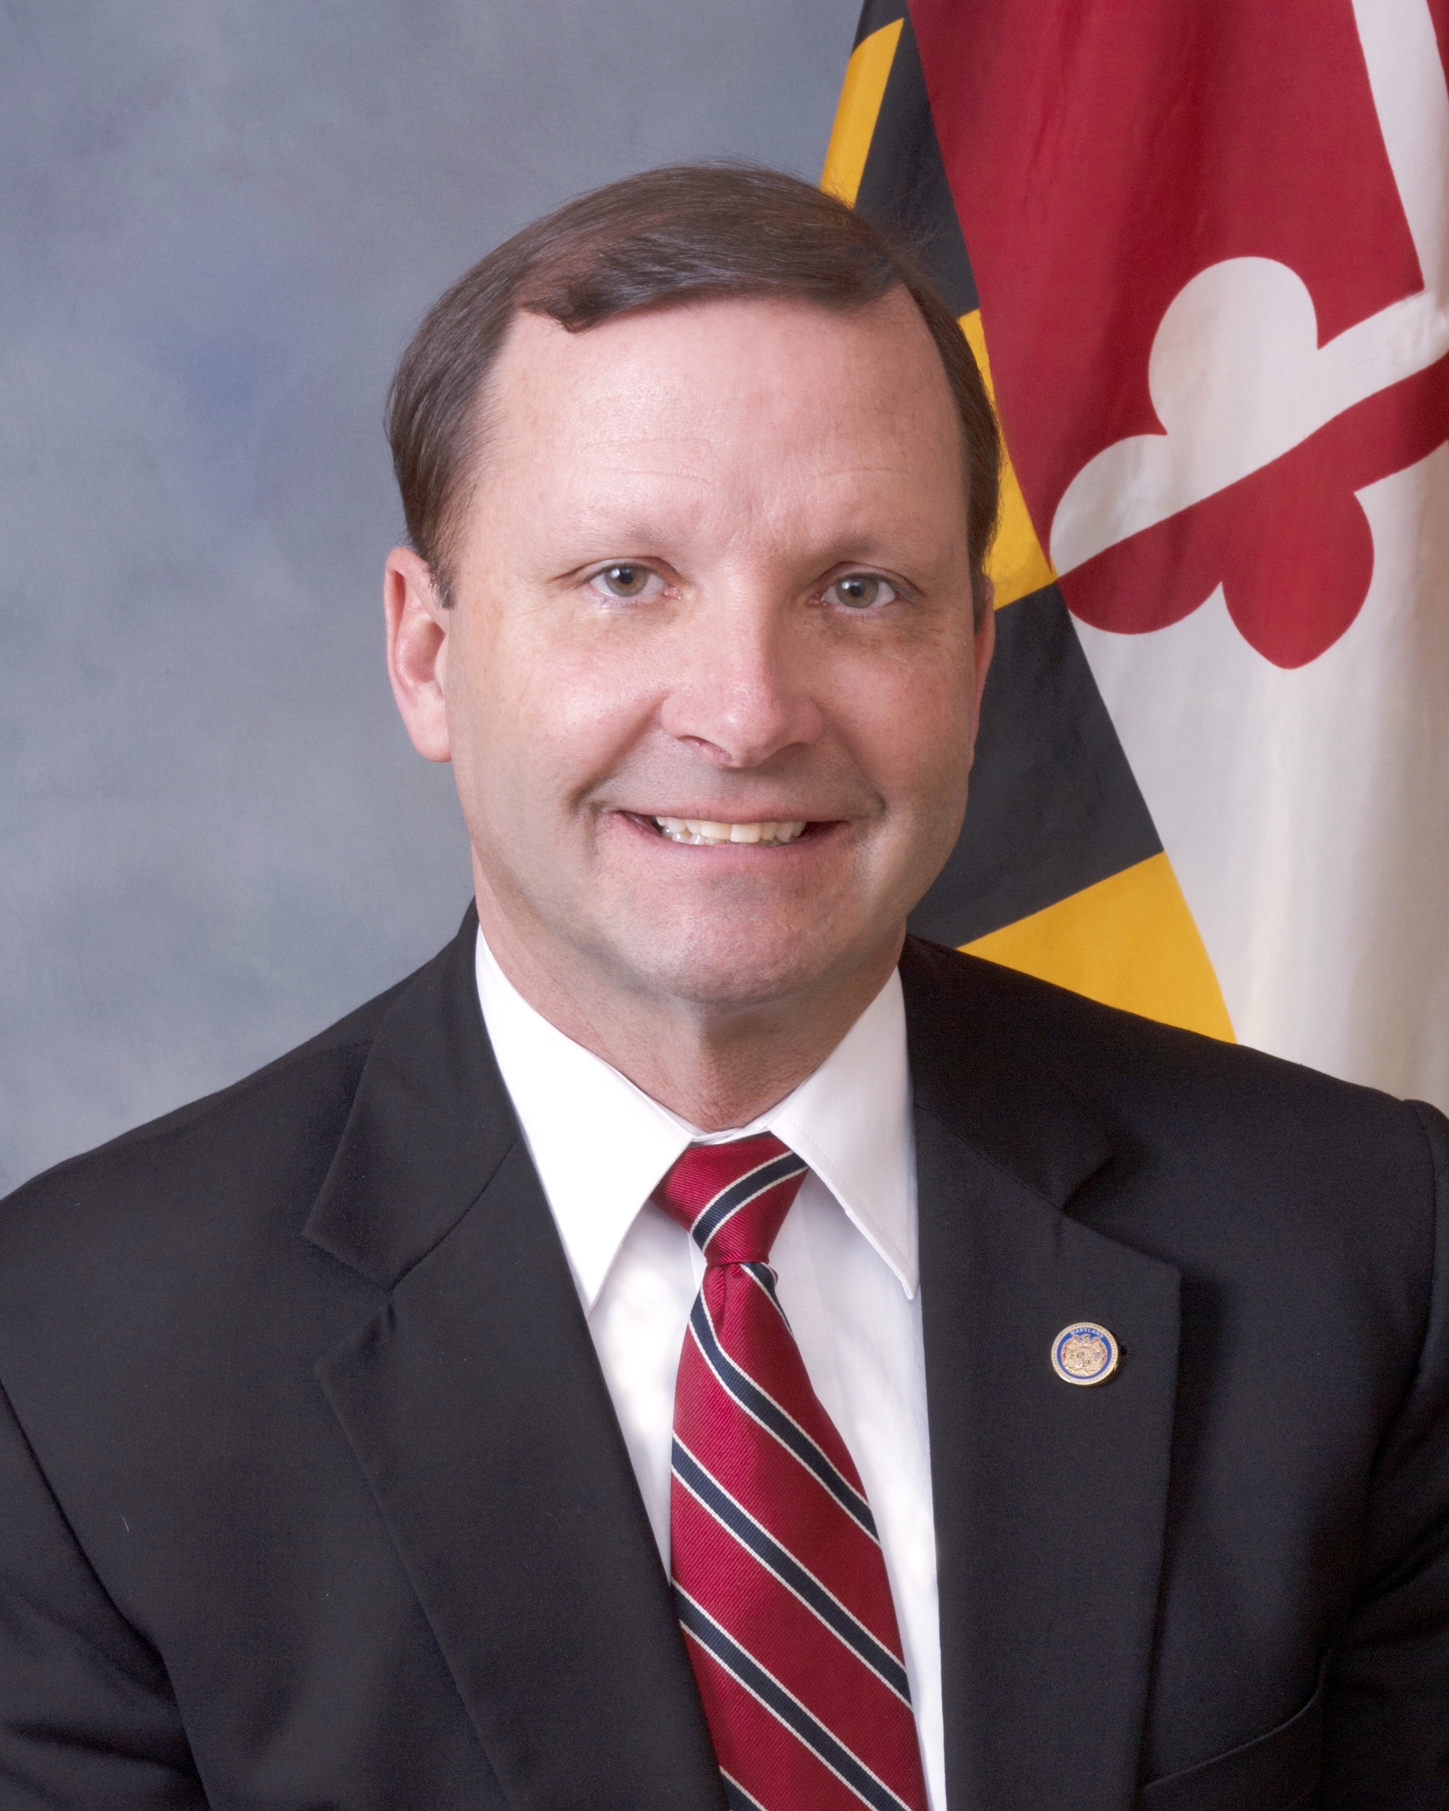
Stephen T. Moyer
Secretary
Department of Public Safety and Correctional Services

At an early age, Steve Moyer, a born and bred Marylander, knew he wanted to follow in the footsteps of his late father, Theodore “Ted” Moyer, who was a retired Maryland State Police Major and former Harford County Sheriff.
His father exemplified the qualities of an outstanding law enforcement officer and set high standards by leading his life serving others.
In so doing, Mr. Moyer has an accomplished and extensive law enforcement background. He served twenty-four years with Maryland State Police (MSP), served as the Deputy Secretary of the Maryland Department of Juvenile Justice for the late Bishop Robinson, and was the MSP Deputy Secretary/Lieutenant Colonel.
Most recently, he was Security Director for the University of Maryland Medical Center (UMMC) in Baltimore for five years prior to being recruited to serve as the Deputy Chief of Police for the Sarasota Police Department in Sarasota, Florida, where he also was the Deputy Emergency Manager for the City.
Mr. Moyer has a Johns Hopkins University Master of Science Degree in Management (Police Executive Leadership Program) and a Towson University Bachelor of Science Degree in Biology.
His training background includes the Federal Bureau of Investigation (FBI) National Academy and the FBI Leadership Program in Counter Terrorism at Harvard University, a United States Secret Service Dignitary Protection Program, and other pertinent experiences in leadership and law enforcement. He is currently an active member in more than ten law enforcement affiliations and associations.
Having spent his entire career in law enforcement and the criminal justice system, Mr. Moyer is keenly aware of the challenges the Department of Public Safety and Correctional Services (DPSCS) faces every day.
As Secretary of DPSCS, Mr. Moyer’s primary focus is on the safety for all of those working throughout the DPSCS system, safety for officers and the community, and seeing to it that DPSCS employees have the highest level of training and equipment needed for the job.

The Hogan-Rutherford Administration and Mr. Moyer have the utmost respect for the outstanding work being done by DPSCS employees who are always there and always keeping Maryland safe.

