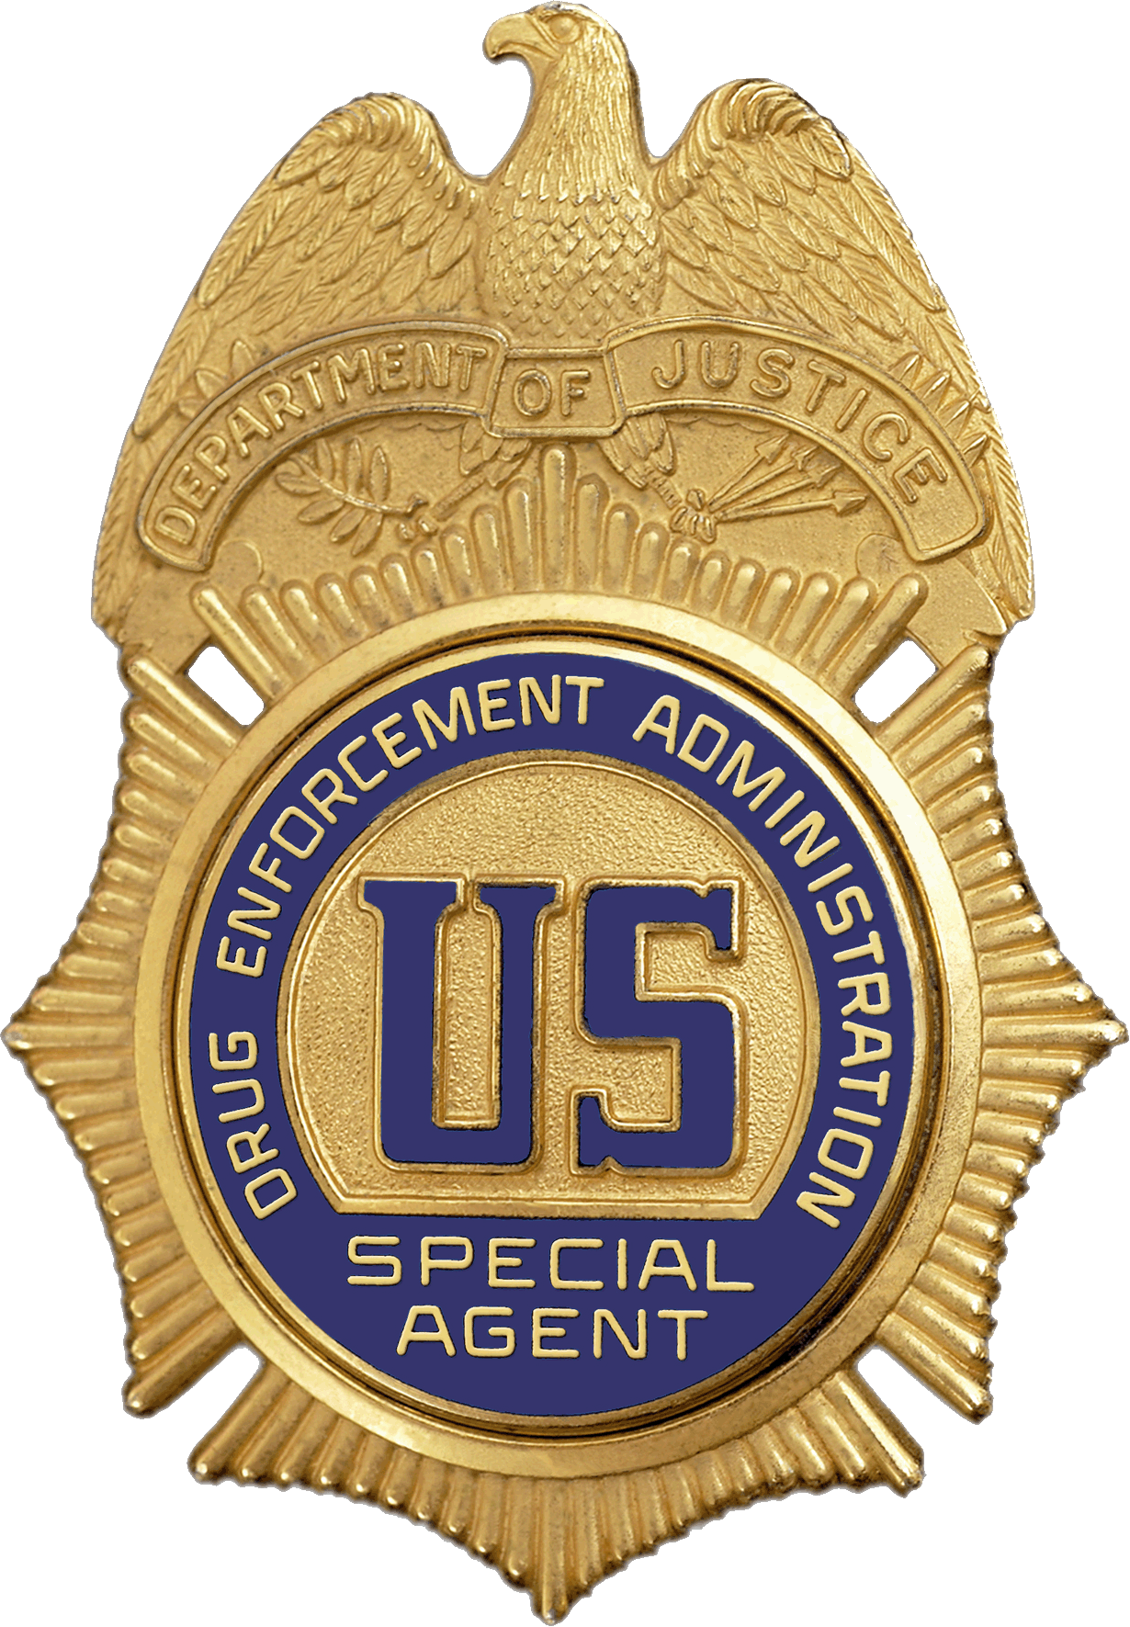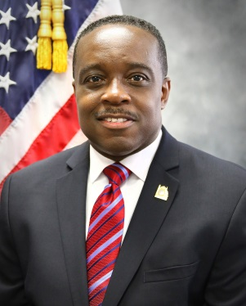
Karl C. Colder
Special Agent in Charge
Washington Division
Drug Enforcement Administration
U.S. Department of Justice

Special Agent in Charge Karl C. Colder has 31 years as a Special Agent with the Drug Enforcement Administration. He currently serves as the Special Agent in Charge of the Washington Division Office, which is covered by offices in the states of Maryland, Virginia, West Virginia and the District of Columbia.

Prior to the Washington Division Office, Mr. Colder served as the Deputy Chief Inspector of the DEA Office of Professional Responsibility. In this position, he served in the Senior Executive Service as the principal advisor to the DEA Chief Inspector on all DEA internal related investigative matters and led one of DEA’s most sensitive and important programs. Heading that office, Mr. Colder ensured DEA’s professionalism, credibility, and longstanding reputation for high integrity was maintained with the public and Congress.

Before being named to the Senior Executive Service, Mr. Colder served as the Assistant Special Agent in Charge the Philadelphia Field Division. Prior to serving as Assistant Special Agent in Charge in Philadelphia, Mr. Colder served as Senior Inspector of the DEA Office of Professional Responsibility’s Northeast Field Office in Newark, New Jersey.

Mr. Colder has also held supervisory positions in the DEA Headquarters Inspections Division, Dallas Field Division, Fort Worth Resident Office and Caribbean Division. Mr. Colder also served in non-supervisory Special Agent positions in St. Croix, U.S.V.I, and in Philadelphia, Pa where he started his career.

Mr. Colder earned a Bachelor of Arts Degree in Political Science and a Bachelor of Arts Degree in Social Relations from Cheyney State University of Pennsylvania, and a Master of Arts Degree in Human Resources Training and Development from Seton Hall University in South Orange, New Jersey. He also currently serves on the Virginia Governor’s Task Force on Prescription Drug and Heroin Abuse.

