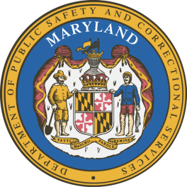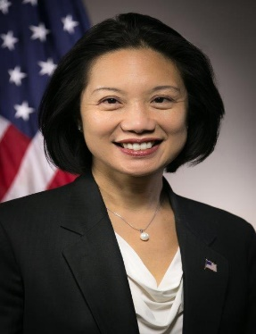
Jessie K. Liu
HIDTA Executive Board Vice Chair

Jessie K. Liu was confirmed by the U.S. Senate on September 14, 2017, as the United States Attorney for the District of Columbia and took office on September 24, 2017. Ms. Liu is a member of the Attorney General’s Advisory Committee, a group of fifteen United States Attorneys who advise the Attorney General and provide input on Department of Justice policies on behalf of the United States Attorney’s Offices.

Ms. Liu was an Assistant United States Attorney in the District of Columbia from 2002 to 2006, prosecuting violent crime, drug trafficking, firearms, and fraud offenses in both the Superior Court and Criminal Divisions, and briefing and arguing appeals in the D.C. Court of Appeals and the U.S. District Court for the D.C. Circuit. She subsequently served in several senior positions in the U.S. Department of Justice, including as Deputy Assistant Attorney General in the Civil Rights Division, Counsel to the Deputy Attorney General for national security matters, and Deputy Chief of Staff for the National Security Division. Immediately prior to her appointment as United States Attorney, she was Deputy General Counsel at the U.S. Department of the Treasury, advising the Secretary of the Treasury and other senior Treasury officials on national security, law enforcement, and intelligence issues.

In addition, Ms. Liu has been a partner at the law firms of Morrison & Foerster LLP, where she was a member of the firm’s Board of Directors, and Jenner & Block LLP, where she was a co-chair of the white collar defense and investigations practice group and served on the firmwide Management Committee.

Ms. Liu clerked for then-Chief Judge Carolyn Dineen King of the U.S. Court of Appeals for the Fifth Circuit in Houston, Texas. She received her A.B., summa cum laude, from Harvard University in 1995 and her J.D. from Yale Law School in 1998, where she was an editor of the Yale Law Journal and editor-in-chief of the Yale Journal of International Law.

